[](https://www.google.co.uk/url?sa=i&url=https%3A%2F%2Fwww.vectorstock.com%2Froyalty-free-vector%2Fcute-brown-bear-cartoon-waving-hand-vector-2023749&psig=AOvVaw2UVwsjaFT4-OewhOVyojle&ust=1592599318248000&source=images&cd=vfe&ved=0CAIQjRxqFwoTCOi-sPucjOoCFQAAAAAdAAAAABAD)[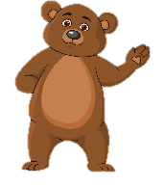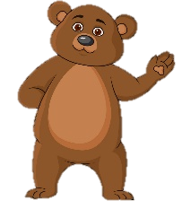](https://www.google.co.uk/url?sa=i&url=https%3A%2F%2Fwww.vectorstock.com%2Froyalty-free-vector%2Ffunny-brown-bear-cartoon-vector-898809&psig=AOvVaw0m5cHMwbxmd1wfzE-vXttB&ust=1592584243759000&source=images&cd=vfe&ved=0CAIQjRxqFwoTCODa6_3ki-oCFQAAAAAdAAAAABAD)

**Class 2 Bears- Summer 2**

[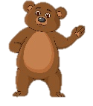](https://www.google.co.uk/url?sa=i&url=https%3A%2F%2Fwww.vectorstock.com%2Froyalty-free-vector%2Ffunny-brown-bear-cartoon-vector-898809&psig=AOvVaw0m5cHMwbxmd1wfzE-vXttB&ust=1592584243759000&source=images&cd=vfe&ved=0CAIQjRxqFwoTCODa6_3ki-oCFQAAAAAdAAAAABAD)

We hope that you had a lovely holiday with your families. We are excited for our final summer term together!

**Class 2 Weekly Summer 2 Timetable**

**What will you need?**

*Indoor and outdoor labelled PE

Kit for a Tuesday and Wednesday.

*If we are lucky enough to have some hot days, please ensure your child comes to school with sun cream on and a sun hat. They may also bring sun cream into school if needed.



**Important Dates**

* 09.06.25 – Year 1 Phonics Screening.

* 24.06.25 – Sports Day.

* 02.07.25 – Whole School Transition Morning.

* 15.07.25 - Whole School Trip.

* 18.07.25 – Trophy Presentation.

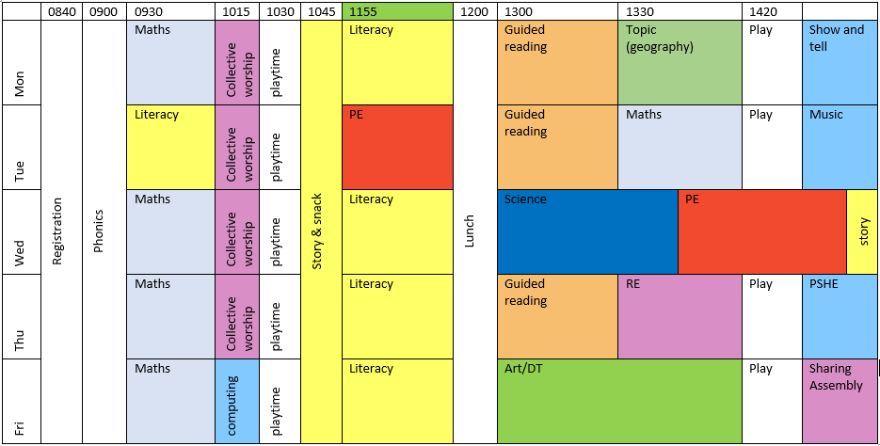

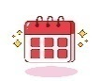[](https://www.google.co.uk/url?sa=i&url=https%3A%2F%2Fwww.twinkl.com%2Fillustration%2Fpe-kit-1&psig=AOvVaw3s5uEczwMIEWeh1BFy7CWd&ust=1592599705677000&source=images&cd=vfe&ved=0CAIQjRxqFwoTCLD8s7OejOoCFQAAAAAdAAAAABAD)

[](http://www.google.co.uk/url?sa=i&rct=j&q=&esrc=s&source=images&cd=&cad=rja&uact=8&ved=0ahUKEwjln4XC64nWAhXBvRQKHaP4AuoQjRwIBw&url=http://laoblogger.com/cartoon-books-pics.html&psig=AFQjCNFr_7_DBVvOch4qyiodQD1MfD1n5A&ust=1504556403601942)

**How can you help at home?**

* **Reading-** Please continue to read and practise phonic flash cards with your child for at least 5 minutes every day and record this in their planners.
* **Phonics-** A phonics task and weekly spellings will continue for **Year 1 and begin again for Year 2 in the place of the Reading Comprehension task.** They will be given on a Friday linking to what we have been learning in class. Please continue to help your child practise these at home.
* **My Maths, Times Table Rockstars + Numbots-** Please continue to encourage your child to go on the following websites at home. My Maths homework will be set twice this half term.
* **Homework book-** Your child will be provided with a new topic homework sheet linking to our new topic “Splish, Splash, Splosh”. Please help your child complete the purple tasks and if you would like to, complete some of the optional white tasks. Please return the homework book to school each Friday to be marked.

[](https://www.google.co.uk/url?sa=i&url=https%3A%2F%2Fwww.carstickers.com%2Fproducts%2Fstickers%2Fstar-stickers%2Fdetails%2Fstars-corner-sticker-2700%2F&psig=AOvVaw3NPz1GZsPx9yzd0nUGMo9b&ust=1592585304332000&source=images&cd=vfe&ved=0CAIQjRxqFwoTCPiupOPoi-oCFQAAAAAdAAAAABAO)[](https://www.google.co.uk/url?sa=i&url=https%3A%2F%2Fpixabay.com%2Fillustrations%2Falphabet-school-cartoon-symbol-abc-3704805%2F&psig=AOvVaw09b16VFzRYsvbM4S8kA82O&ust=1592862393193000&source=images&cd=vfe&ved=0CAIQjRxqFwoTCMDL7P7wk-oCFQAAAAAdAAAAABAD)

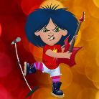

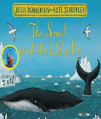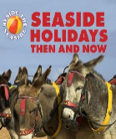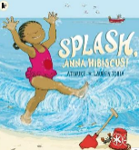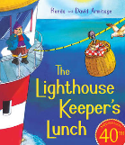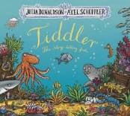

Geography

Continuing our work with compasses from Summer 1 to help us create our own maps.

Looking at key physical and human features and where we might find these.

**Bookshelf**

Science

**Living things and their Habitats**

Looking at different habitats that animals live in. Describing how animals get their food from plants and other animals by beginning to look at simple food chains.

**Topic: Splish, Splash, Splosh!**

Year 1&2’s Learning Tree (Summer Term 2)

PSHCE

*Looking at our achievements in Year 1/2 and setting targets to improve.

*Discovering how we change and grow from young to old.

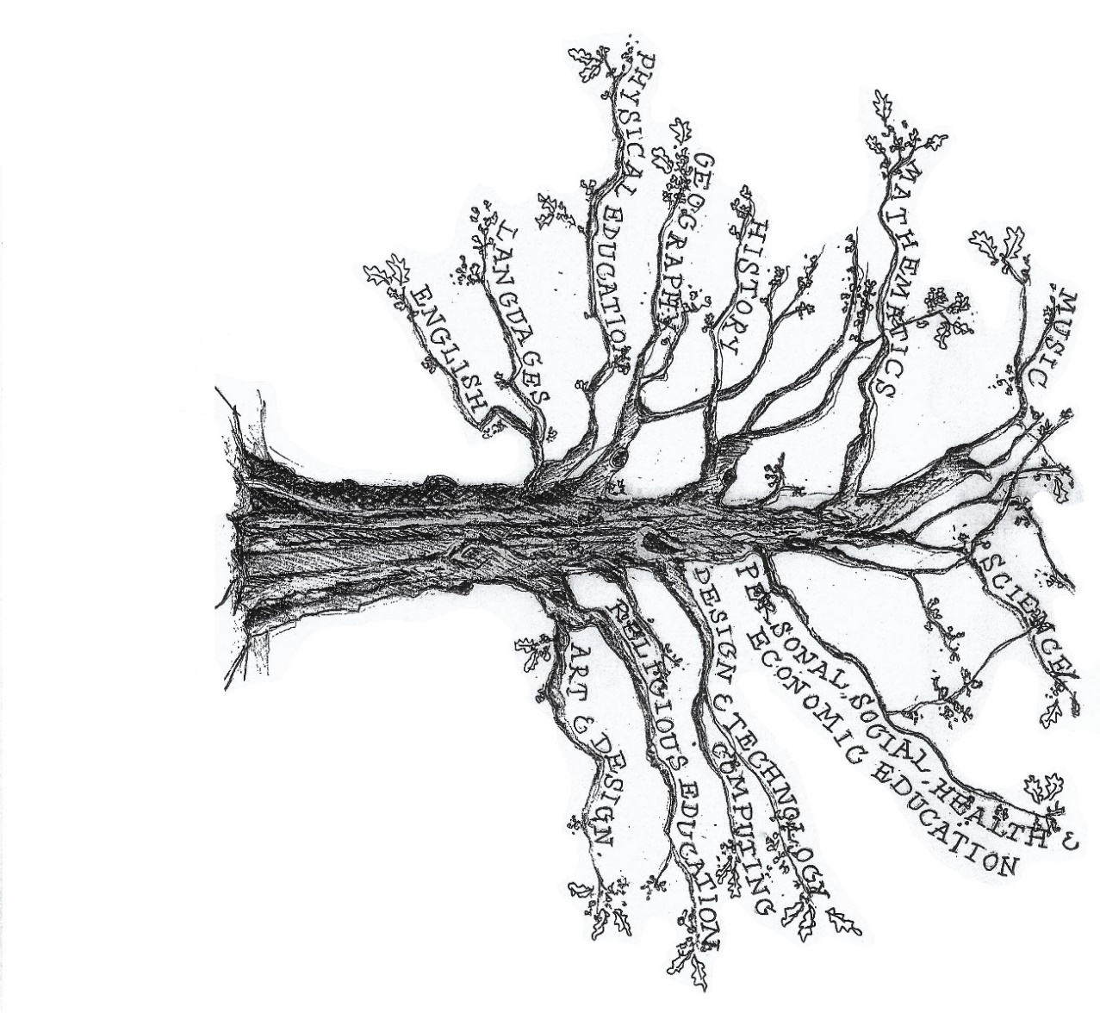

[](https://www.google.co.uk/url?sa=i&url=https%3A%2F%2Fwww.pinterest.com%2Fpin%2F83738874305027941%2F&psig=AOvVaw17y3xahYwN4XVR_1e-hz9G&ust=1592571109951000&source=images&cd=vfe&ved=0CAIQjRxqFwoTCICe0u6zi-oCFQAAAAAdAAAAABAE)

Art & Design Technology:

*Developing our Art techniques to create beach scenes using printing, patterns and outdoor materials.

*Creating our own yummy ice lollies.

Computing

**Programming and Coding**

*Learning all about algorithms and how to use them on Purple Mash to make items move on a screen.

[Purple Mash | Thomlinson Junior School](https://www.google.co.uk/url?sa=i&url=http%3A%2F%2Fwww.thomlinson.cumbria.sch.uk%2Fpurple-mash%2F&psig=AOvVaw1ncBqIv0zRlIKFjdwFERvi&ust=1592570341989000&source=images&cd=vfe&ved=0CAIQjRxqFwoTCIj8_v6wi-oCFQAAAAAdAAAAABAJ)

[](https://www.google.co.uk/url?sa=i&url=https%3A%2F%2Fwww.vectorstock.com%2Froyalty-free-vector%2Fcartoon-artist-boy-vector-1797601&psig=AOvVaw3MtAJE-tkiXL5OQmLBd_t2&ust=1592575240968000&source=images&cd=vfe&ved=0CAIQjRxqFwoTCIDt5aHDi-oCFQAAAAAdAAAAABAK)

Religious Education

How should we care for the world and for others?

Maths

*Measurement (capacity, length and mass)

*Recap of all four methods (+,-,X, ÷)  
*Statistics

*Time

*Money

[Brown Cross Clip Art at Clker.com - vector clip art online ...](https://www.google.co.uk/url?sa=i&url=http%3A%2F%2Fwww.clker.com%2Fclipart-brown-cross.html&psig=AOvVaw3rzfKDntbtEV8yrKHM80xW&ust=1592578397927000&source=images&cd=vfe&ved=0CAIQjRxqFwoTCLiLsYDPi-oCFQAAAAAdAAAAABAD)

[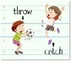](https://www.google.co.uk/url?sa=i&url=https%3A%2F%2Fwww.dreamstime.com%2Fillustration%2Fball-boy-throw.html&psig=AOvVaw3HlOswO775JsQHUx0hRTLO&ust=1592570513079000&source=images&cd=vfe&ved=0CAIQjRxqFwoTCKi7ltWxi-oCFQAAAAAdAAAAABAD)[happy smiling pencil guy cartoon character Wall Mural • Pixers ...](https://www.google.co.uk/url?sa=i&url=https%3A%2F%2Fpixers.uk%2Fwall-murals%2Fhappy-smiling-pencil-guy-cartoon-character-39193752&psig=AOvVaw0X8JWAdEirsTT5DIKwANTY&ust=1592575744129000&source=images&cd=vfe&ved=0CAIQjRxqFwoTCIjf8Y_Fi-oCFQAAAAAdAAAAABAD)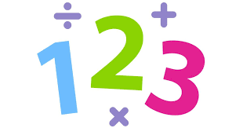

PE

Athletics- preparing our bodies for Sports Day activities (running, jumping,

throwing).

Outdoor Adventures- Following simple

routes and pathways.

Super Start- Art Day! Let’s get creative...

Fabulous Finish- Trip to York Maze!

English

Story- linking to the book “The Lighthouse Keeper’s lunch”.

Non-Fiction Fact File- Creating a creature that lives underneath the sea. Writing about what it looks like, what it eats and where it lives.

Instructions- Explaining how to make yummy ice lollies.

