Sunday 2nd January 2022
Dear Parents/Carers,

I would like to wish you all a Happy New Year; hopefully you have enjoyed a relaxing and joyful Christmas. We are looking forward to welcoming everyone back on Wednesday 5th January 2022; following our INSET day on Tuesday 4th January.

As you will no doubt be aware, cases of COVID-19 have continued to increase both nationally and locally over the last few weeks. With the aforementioned in mind, I wanted to make you aware of the mitigations that will be implemented from Wednesday 5th January 2022:
- After school clubs will not resume until Monday 28th February 2022, at the earliest (this will be kept under review).
- Breakfast Club will continue with the partitioned seating plan which was actioned prior to Christmas.
- Mask wearing will be required amongst staff (in communal areas) and parents/carers will be encouraged to wear them at drop off & pick up (unless medically exempt). The aforementioned is especially important given the highly transmissible Omicron variant of COVID-19.
- Continue to reinforce the importance of regular hand washing with soap and water or using hand sanitiser when soap and water are not readily available.
- Continue to promote good respiratory hygiene and “Catch it, Bin it, Kill it” messages to encourage children to catch coughs and sneezes in a tissue and dispose of it in the nearest waste bin.

If confirmed cases reach 10% (either within a class or across the school), the following will be actioned:
- At the start of the day – Parents/carers instructed to line up using marked dividers on pavement at Elvington Lane entrance, in allotted time slot for child’s year group. Children to be handed over at the school gate to a member of staff. Parents/carers not permitted on school site and only allowed in school building when strictly necessary, by appointment.
- At the end of the day - Parents/carers advised to arrive at earliest possible listed time for child’s year group. They should line up on the pavement outside school, respecting social distancing measures. Their child will be returned to them when they reach the front of the parent/carer line.
- The children’s classrooms will be arranged differently. This will result in pupils sitting side by side and facing forwards, rather than face to face or side on.
- Class sized bubbles will be implemented and will stay together for all activities - separate from other class bubbles.
- Staggered break times (including lunch), so that all children are not moving around the school at the same time.
- Whole-school Collective Worship and Sharing Assemblies will not take place in the hall. Collective Worship and the sharing of certificates will still take place in class bubbles via Google Meet.
- Walky-talkies will be used by the staff to facilitate communication and ensure there are no conflicting movement of groups.
- PE kits will come into school on a Monday and return home on a Friday. Reading books will be provided once a week (on a Monday), and should be returned on a Friday. This will allow 48 hours before the books are passed onto another child.
- School trips (including residentials) will not take place.
- The school will work closely with the local health protection team (HPT) and implement provisions as advised by the team.

Information on the changes to the self-isolation period for individuals who test positive for COVID-19
Since Wednesday 22nd December, the 10 day self-isolation period for people who record a positive PCR test result for COVID-19 has been reduced to 7 days in most circumstances, unless you cannot test for any reason.

Individuals may now take LFD tests on day 6 and day 7 of their self-isolation period. Those who receive two negative test results are no longer required to complete 10 full days of self-isolation. The first test must be taken no earlier than day 6 of the self-isolation period and tests must be taken 24 hours apart. This also applies to children under 5, with LFD testing at parental or guardian discretion. If both these test results are negative, and you do not have a high temperature, you may end your self-isolation after the second negative test result and return to your education setting from day 8.

Anyone who is unable to take LFD tests will need to complete the full 10 day period of self-isolation. Further information is available in the stay at home: guidance for households with possible or confirmed COVID-19 infection.
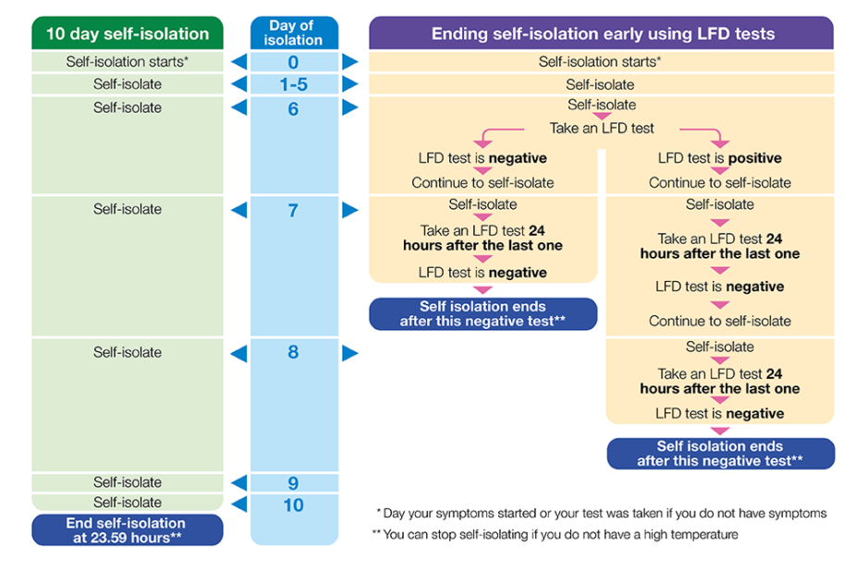

Daily testing for close contacts of COVID-19
People who are fully vaccinated, or children and young people aged between 5 and 18 years and 6 months, identified as a close contact of someone with COVID-19, should take an LFD test every day for seven days and continue to attend their setting as normal, unless they have a positive test result or develop symptoms at any time.

Children under 5 are not being advised to take part in daily testing of close contacts. If a child under 5 is a contact of a confirmed case, they are not required to self-isolate and should not start daily testing. If they live in the same household as someone with COVID-19 they should limit their contact with anyone who is at higher risk of severe illness if infected with COVID-19, and arrange to take a PCR test as soon as possible. They can continue to attend an education or childcare setting while waiting for the PCR result. If the test is positive, they should follow the stay at home: guidance for households with possible or confirmed COVID-19 infection.

Joint Committee on Vaccination and Immunisation (JCVI) advice on COVID-19 vaccination for at-risk 5 to 11 year olds
Children aged 5 to 11 years in a clinical risk group, or who are a household contact of someone who is immunosuppressed, will be offered two doses of the vaccine, 8 weeks apart. Further advice about vaccinations for this group can be found at: www.gov.uk/government/publications/jcvi-update-on-advice-for-covid-19-vaccination-of-children-and-young-people/jcvi-statement-on-covid-19-vaccination-of-children-and-young-people-22-december-2021.

Road Closure
I would also like to make you aware that the section of Elvington Lane, immediately outside of school, is currently closed. Please take this into account when planning drop off and collection.
Up to date information can be found at: www.yorkshirewater.com/your-water/elvington-lane-road-closure.

As both a Headteacher and a parent, I realise how unsettling and potentially upsetting the ongoing uncertainty is for everyone. Please do not hesitate to contact me via email (head@elvingtonprimary.org.uk), if you have any questions. Although, unfortunately, I cannot guarantee to have the answers. Should there be any new directives from the DfE, I will contact you at the earliest opportunity to outline any amended arrangements.

Thank you for your continued support and cooperation in working together to ensure the safety and well-being of all those in our school community.

Yours sincerely,
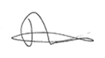
Mr. Andrew Buttery

