Tuesday 13th July 2021
Dear Parents/Carers,

As you will no doubt be aware, there has been much reported in the media this week about rising infection rates and the implications this is having on bubbles, or whole schools, needing to close (Fulford Secondary School is a local example of this).

On advice from Public Health England (PHE), pupils in primary schools and children in nursery settings are not included in the rapid asymptomatic testing programme.

PHE has advised that there are currently limited public health benefits to testing primary-aged pupils with lateral flow devices (LFD). In addition, primary-aged pupils, particularly younger children, may find the LFD testing process unpleasant and are unable to self-swab.

We are advising that primary-aged pupils should only be tested if they are symptomatic, in which case their families should follow the guidance for households with possible or confirmed coronavirus (COVID-19) infection and book a PCR test for the child (www.gov.uk/get-coronavirus-test).

The main symptoms of COVID-19 in children are:
- a high temperature,
- a new, continuous cough – this means coughing a lot, for more than an hour, or 3 or more coughing episodes in 24 hours,
- A loss or change to sense of smell or taste – this means they cannot smell or taste anything, or things smell or taste different to normal.

There have been a number of other symptoms widely reported for children who have tested positive for COVID-19, especially with the Delta variant. These include:
- nasal congestion or runny nose,
- sore throat,
- diarrhoea and vomiting,
- stomach pain,
- headache,
- Muscle ache (myalgia).

While it does seem like children can get a wider range of coronavirus symptoms than adults, these symptoms may also be a sign of another infection or illness entirely. It is important not to miss the signs of another serious illness.

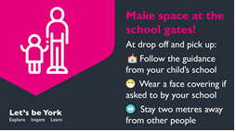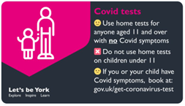
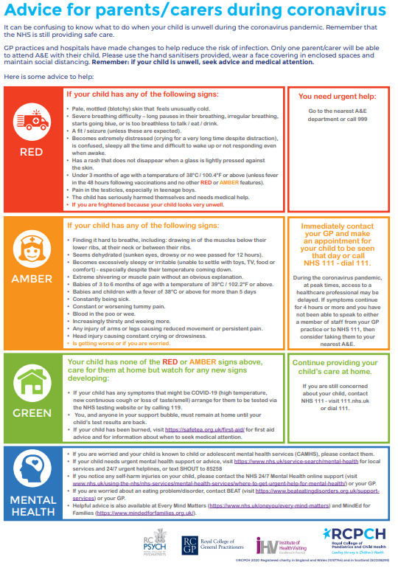
Yours sincerely,
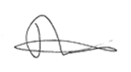
Mr. Andrew Buttery

