Tuesday 5th January 2021
Dear Parents/Carers,
I would like to thank all members of our school community for the overwhelmingly positive response to the unprecedented situation that has affected and will continue to affect us all. Understandably, parents/carers and staff alike are facing enormous pressures and want to do their very best for their loved ones – to keep them safe and in good health.

In this letter I will attempt to compile key information and provide answers to range of questions that I have been asked.

Will Elvington Church of England Primary School be closed as of Monday 4th January 2021?
We will be closed to ‘the majority of children and families’. We have a statutory responsibility to follow the Government’s decision. However, I have a duty of care to my staff, and as a result, we will be ensuring that we follow a system to reduce the number of teaching staff working with a bubble at any one time. This will also allow us to facilitate our COVID-19 remote/blended learning curriculum continuity offer: www.elvingtonprimary.org.uk/general/covid-19-remote-blended-learning-curriculum-continuity.
All staff who are able to, will continue to work in school and we will be very much continuing to run the school and ensure the wellbeing of all children in our care, whether this be on site or remotely.

What does ‘closed for the majority of children’ mean?
It is our civic duty during this national emergency to adhere to the principles of the Government directive, which is to limit numbers of pupils remaining in school as far as possible, so as to lower the risk that the virus will spread.
A parents/carers guide to critical key workers and vulnerable children definitions is available by following this link: www.gov.uk/government/publications/coronavirus-covid-19-maintaining-educational-provision?utm_source=4%20January%202021%20C19&utm_medium=Daily%20Email%20C19&utm_campaign=DfE%20C19.
I cannot stress enough how important it is that parents/carers follow the guidance set out by the Government which aims to minimise the risk of the COVID-19 virus spreading and infecting vulnerable people in our communities. The guidance states that if children can stay at home then they should and our expectation is that parents/carers do all they can to ensure that is the case.
I would encourage employers to be as flexible as they can to allow parents/carers to care for their children so as many people as possible follow the social distancing advice which has been rolled out across the country.

When will the school be open?
Those parents/carers who are within the categories mentioned in the link above, and have a child/ren who cannot be ‘safely cared for at home’, will be able to access school between 8.40am to 3.10pm, if they are in either Class 1 or 2 (this will be one bubble), and between 8.50am to 3.20pm, if they are in either Class 3, 4 or 5 (this will be another bubble) each week day, until further notice.
Breakfast Club will be open to the aforementioned children between 7.45 and 8.45am.
Mrs. Challis has informed me that Elvington out of School Club will continue to operate. However, bookings must made 48 hours in advance…

Will Elvington be open across the February half term holiday for children of key/critical workers and vulnerable children?
I am unable to guarantee provision for childcare across the half term holiday at this time. Every effort will be made to do so but a decision cannot be made until closer to the time. At this point however, our energy is focused on provision until the end of this half term.

What will children who are in school do? Will they have access to the full curriculum?
The children who attend school will be working on the same home learning projects/lessons as those individuals staying at home.
Children who are in attendance will need to wear their normal school uniform and bring in either a packed lunch or have a school dinner. It would also be appreciated if they could bring a PE kit to school.
We will care for your child/ren and make sure they are safe, however, we will not be able to offer access to the full curriculum.

How will my child’s education continue if they are not in school?
The teaching staff have created home learning resources (using Google Classroom) which will be sent via email. We will be utilising this electronic approach to enable home/school communication and learning. Please look out for bespoke projects which will be made available via email. This will include a number of ‘live lessons’ via Google Meets.

I am considered a ‘key/critical worker’ or have a ‘vulnerable child’ but I don’t want to send my child in to school, do I have to?
Many parents/carers working in these critical sectors may be able to ensure their child is kept at home. Every child who can be safely cared for at home should be. This is an offer to parents and carers and there is no requirement for parents and carers to send their children to school, if they do not need or wish to do so.
For vulnerable children, your child’s social worker will work with you to assess the best option for your child.

Would it be possible to borrow a Chromebook from school?
Unfortunately, we are unable to loan out Chromebooks. We have a very limited number which will be in use by the children receiving school based care. Secondary to this, our insurance would not cover this equipment away from the school building.

To close, can I please reinforce that the Government have strongly advised that, if you are able to keep your child at home, it is very important that you do so to limit the numbers of children in school. This is in order to try to prevent the spread of Coronavirus to other children; the wider commute and my staff team.

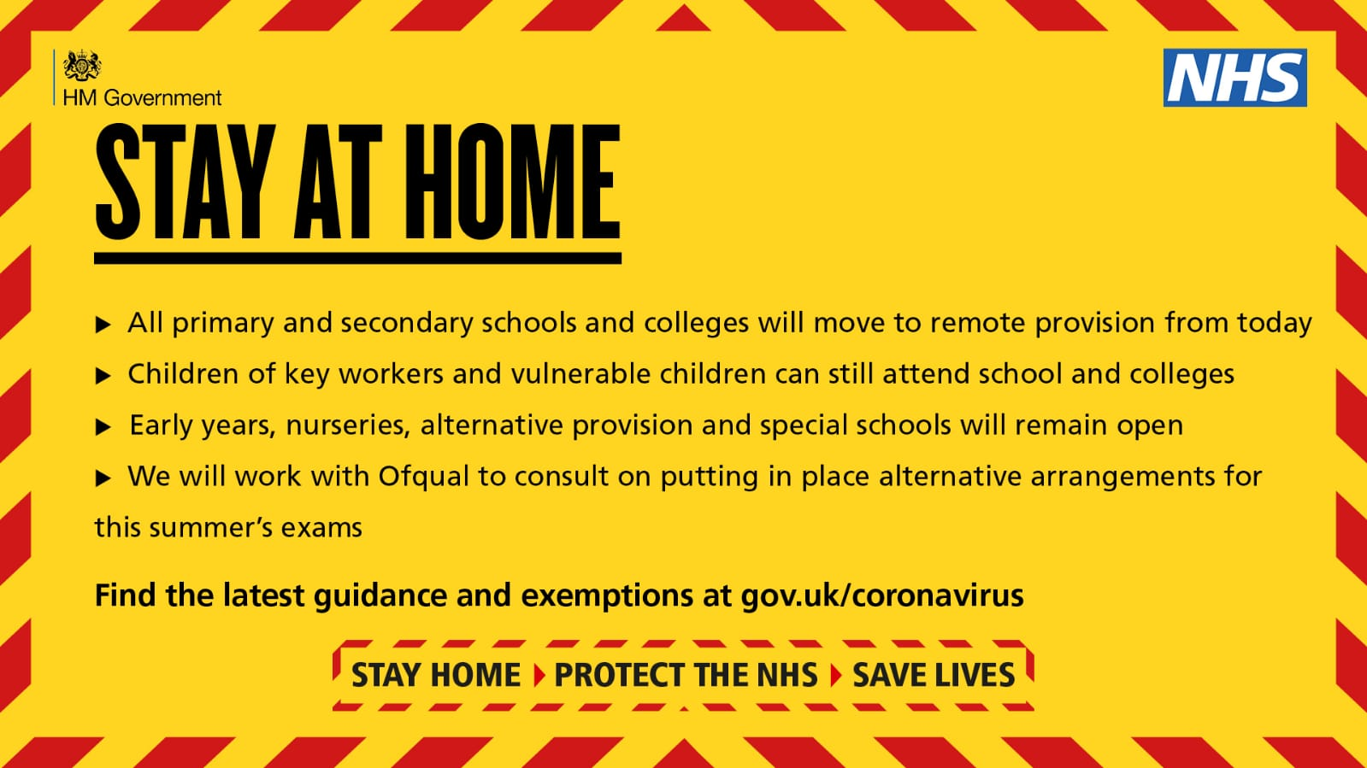
In the event that ‘on site’ education is restricted in the future, available places will be strictly allocated to children in the following priority order:

1. Children who have a child protection plan, are “looked-after” or are identified as “in need” by social services or the school
2. Children with significant special education needs in receipt of a statutory EHCP (education, health and care plan)
3. Children adopted from care
4. Children identified by the school as “young carers”
5. Children with both parents/carers working in jobs critical to the frontline COVID-19 response (or one parent/carer in the case of single parents/carer households)
6. Children with both parents/carers working in jobs critical to the COVID-19 response (or one parent/carer in the case of single parents/carer households)
7. Children with special educational needs - who are not in receipt of an EHCP - but are identified by the school as vulnerable
8. Children with one parent/carer with jobs critical to the frontline COVID-19 response
9. Children with one parent/carer with jobs critical to the COVID-19 response.

*Frontline means being unable to carry out your work from home.

May I once again thank you all for the support and kindness you have shown to each other, to our children, my staff and to the wider community. May you take comfort at this time in the kind acts and generosity of family, friends and colleagues…

Yours sincerely,

Mr. Andrew Buttery

