Tuesday 12th January 2021

A guide to connecting to Google Classroom from different devices

Dear Parents/Carers,

I am aware that some families in Elvington and currently experiencing internet connection issues. Please see the guide below, as this could allow you to access Google Classroom from a different device.

We have a small number of Vodafone SIM cards, which have 30GB data allowance valid for 90 days. If the aforementioned would be helpful, please contact me via email – head@elvingtonprimary.org.uk.

iPhone or Android Phone
There is a Google Classroom app in both the App Store on apple devices or on the android App Store. Look out for this app logo:
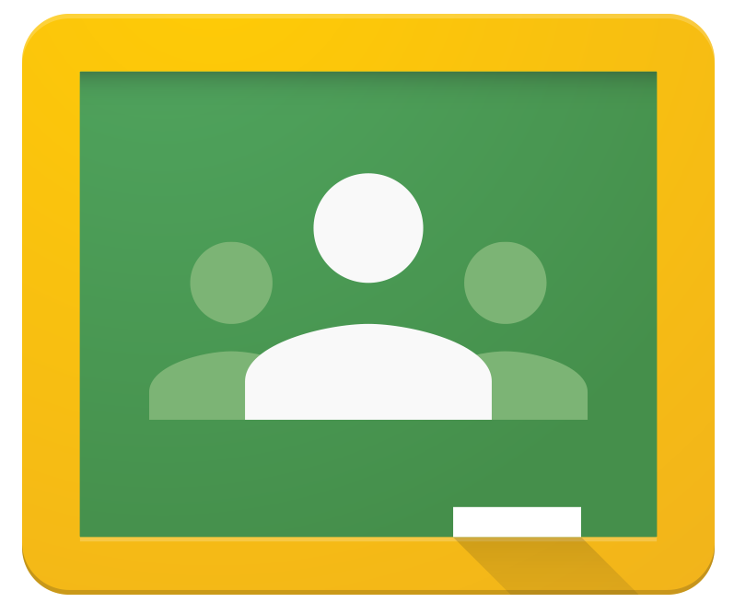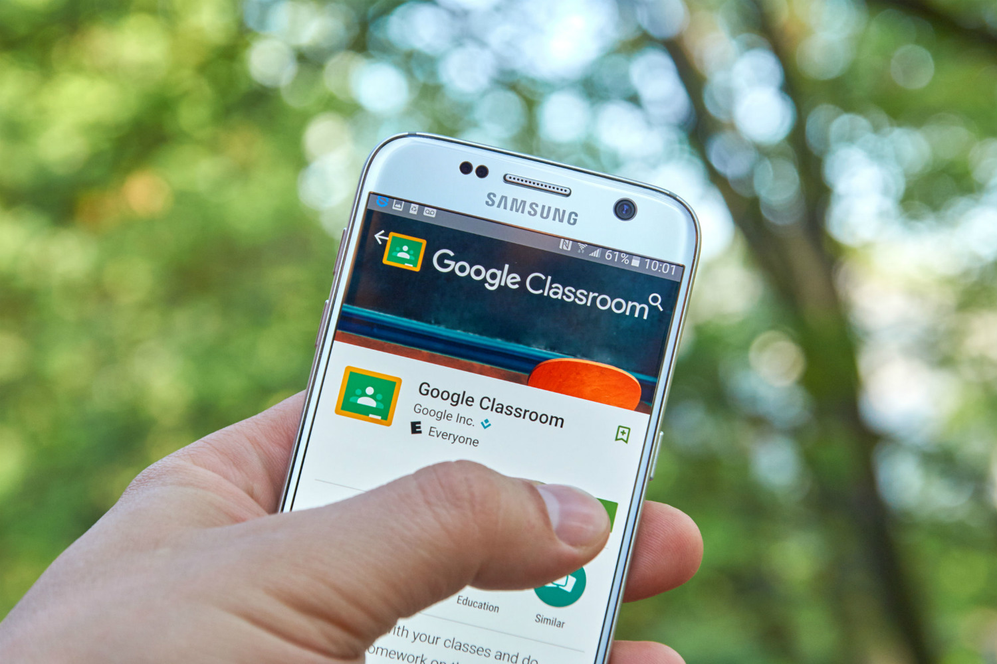

Tablet
There is a Google Classroom app in both the App Store, for Apple devices or on the Android App Store. Watch this video to help: www.youtube.com/watch?v=8pueFFwwQuQ
Look out for this app logo:
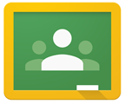

Amazon Fire
You will need to download Google Play to be able to download Google Classroom and other useful apps. Watch this video www.youtube.com/watch?v=5YejBlzFytE or read this article to help www.androidpolice.com/2020/12/25/install-play-store-amazon-firetablet/

Nintendo Switch
You will need to go to the settings button (scroll across the bottom). Select Internet and internet settings. Once here, you select your internet provider and select change settings.

- Now choose DNS settings. Change it to manual.
- Now choose Primary DNS settings.
- Now change the code to: 045.055.142.122 (this is Google’s browser setting).
- Press ok. Press Save.
- Now select: connect to this network. This will look like it hasn’t worked but just click Next.
- Then a white page will appear. Be patient!

Now press continue to Google. Now you can search google classroom. Watch here: www.youtube.com/watch?v=He1CLe3uldg.

Xbox
- Plug a keyboard into the Xbox USB slot.
- Go to my games and apps.
- Find and select Microsoft Edge (may have to download, it's free).
- Navigate to your online learning platform.

PlayStation
- Identify the PlayStation internet browser icon (WWW with dots around it).
- Press the PlayStation logo on the controller.
- Go to the library and find options for games and applications.
- Go to applications and you will find the internet browser.
- Navigate to your online learning platform and log in as usual.

I would like to reassure you that through these challenging and uncertain times, we will continue to do all we can to support our families.

Yours sincerely,

Mr. Andrew Buttery

