Year 1 Home Learning Tasks- Week 1
Weekly activities: Independent reading each day, Times Table Rockstars or Numbots.
Once you complete the activities, please share these with us on our twitter page @Class2elves or @Class1elves
Make a game of snap using the Phase 5 tricky words  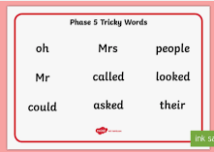 | 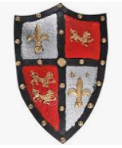  Create a ‘Coat of Arms’ shield. Take a photo of your shield and explain underneath what the different parts symbolise to you. | Explore Purple Mash and find your favourite activity.  
  Choose a challenge….  - Counting in 2’s.  - Counting in 10’s and 5’s.  - Counting in 3’s  Don’t forget to improve your timetable skills on Timetable Rock stars. | Family Activity:  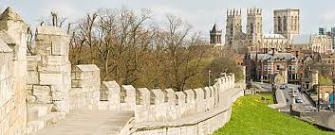  York Bar Walls  What can you find out using the Internet?  Remember to keep safe online. | Could you be a medieval jester?  Can you perform some of the different acts a jester would have done at a medieval banquet?    You could try….  - Juggling  - Telling jokes  - Singing  - Dancing
Diary Entries  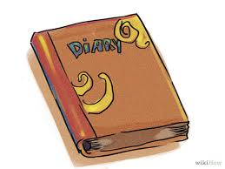  Choose a day and write your own diary entry. | Create a rainbow for your window    “You can’t have a rainbow without the rain.”  Paint a picture of a rainbow and place it in your window to spread hope. Go for a walk and see if you can spot any rainbows in windows around Elvington. | Go outside and find some exciting leaves etc. Can you write a list of ingredients for your own wizard’s potion?    Year 1 – 5 ingredients  Now try writing instructions for  How to make your potion.

