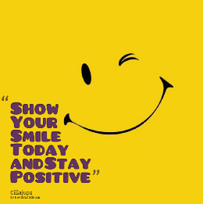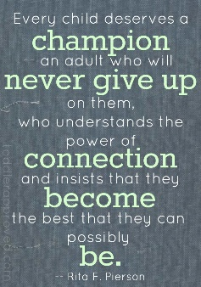

**Maths**

Arithmetic Practice: complete (30 min) and check answers using a calculator.

Rounding: complete as many questions as you can. Extension: create some rounding questions of your own!

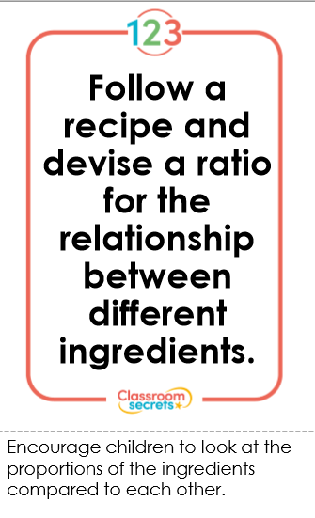

**Twitter:** Tag us in pictures of you learning from home! @Class5elves

**Topic:**

Log on to Purple Mash and follow the route below to complete the task:

Home/Topics/Bronze Age/A Bronze Age Child’s Day

Dear Parents,

Here is an overview of tasks we’d like the children to be completing at home over the forthcoming weeks. We are committed to ensuring that your child is still learning as much as possible and endeavour to do our absolute best to keep this happening.

Warmest regards,

Mrs Haffey, Mrs Marjoram and Mrs Bailey

YEAR 6 HOME LEARNING

**Family Time:**

Rediscover a board game that you haven’t played in a while!

**Daily Reading!**

Children should still be reading daily and have a signed signature in their planner. This is a great opportunity to read some good books – us adults certainly will be!

You could even write a book review – use a creative way to present it.

**Writing**

Go to <http://www.pobble365.com/>

Complete the daily work for each picture on the current date. We would love you to share the writing with us that you produce – let your imagination run wild!

**PSHCE -wellbeing:**

Complete the attached self-esteem sheet- your own thoughts and opinions are important! (There is no right/wrong)

Follow a ‘Just Dance’ routine from YouTube or create your own!

**Websites to access:**

Purple Mash

Times Table Rockstars

Lexia (if you have a login)

<https://www.khanacademy.org> **(free to register for online maths lessons and skill practice.)**

<https://www.pobble365.com/> **(a picture a day with writing and SPAG opportunities)**

**Spelling, Punctuation and Grammar (SPAG)**

Log on to Purple Mash and try out this spelling quiz:

Home/English/Spelling/Year 6/ SPR2 WK1 Quiz

Complete the silent letters crossword

How many adverbs can you think of that don’t end in ‘ly’?

**Reading Comprehension**

Read the extract from The Wind in the Willows and answer the questions fully.

Write some of your own questions about a book you are currently reading.