Year 5 Class 4 Homework
Weekly activities: Spelling activities, independent reading, times tables, Times Table Rock Stars, Lexia (for those of you who are signed up)
Get Reading!  Read the attached story ‘Theseus and the Minotaur.  Answer the comprehension questions.  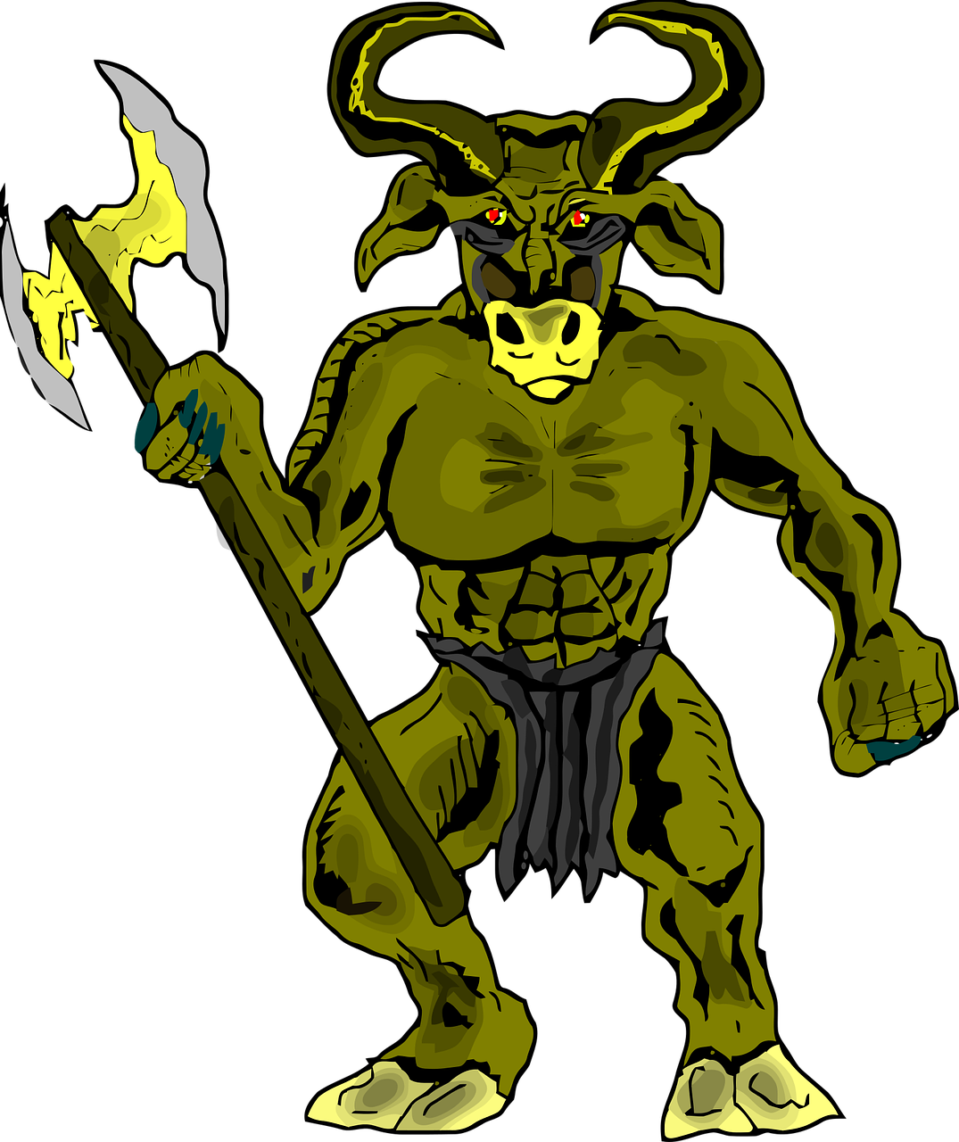 | Get baking and measuring!  Use your measuring skills to bake a tasty treat!  How many people would it feed?  Can you calculate how much ingredients you would need to make the recipe for more people eg 8 people? 12 people? | Get Coding!    Log in to your Purple Mash account (written in your planner). Use the coding activity to complete the different challenges.  Purple Mash/ Computing/ 2Code/  Gibbon section –Guard the Castle game  
Get discussing!  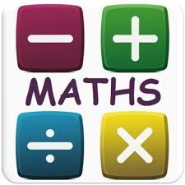  Have a go at the attached maths discussion tasks (angles, area, perimeter) | Get active!  Use the free Go Noodle website to get moving with some crazy characters! Or…  Create your own circuits with different stations as we have done in PE (high knees, star jumps etc) Or…  Complete your own daily mile running around your garden.
Get playing!  Play the Stone Age survival game  What do you notice are threats and assets?  https://gridclub.com/activities/stone-age-survival | Get writing!  Literacy - free writing activity  Pick your favourite genre from this year so far (story, diary, setting description, news report, information text, formal letter, poetry). Write about anything of your choice. | Get socialising!  Put down those electronical devices for a day!    Play a board or card game with your family.

