Class 1 Homework Week 2
Weekly activities:
To practise sounds and to look at and enjoy a range of books with family members…

In addition, please could children complete the following tasks. Please try to complete six tasks but if you would like to do them all, feel free to do so. Don’t forget to take a photo and put it onto Tapestry.

Make teen numbers using sticks and pebbles from the garden.  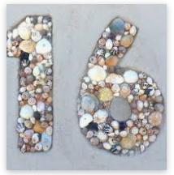 | Paint a castle and then label it.  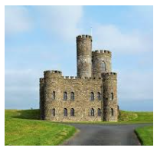 | Make a sandwich with a family member. Talk about halves and quarters as you cut your sandwich.  
Make a paper aeroplane and write a message to a school friend. Share it on Twitter or Tapestry.   | Play a family game. Remember the importance of taking turns.  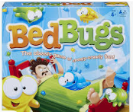 | Go on phonics play and play a game from Phase 2 up to Phase 4.  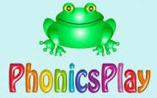
Go outside and do some star jumps. Count in 2’s as you jump. What other exercises can you do as you count in 2’s?   | Roll a die and then double the number. Now try and write the complete calculation sentence.   | Write a sentence and include the word they.  

