Class 1 Homework Spring 2
Weekly activities:
To practise sounds and to look at and enjoy a range of books with family members…

In addition, please could children complete the following tasks? Please try to complete six tasks but if you would like to do them all, feel free to do so. Don’t forget to take a photo and put it onto Tapestry.

Learn to play noughts and crosses and try to win a game  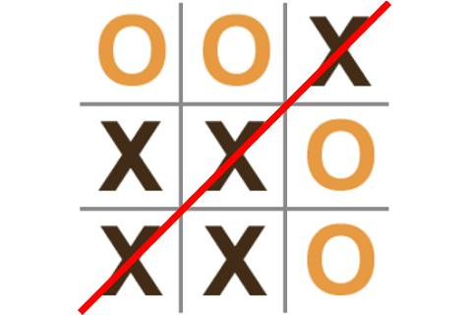 | Make a crown fit for a King or Queen   | In the garden create a repeating pattern using leaves and sticks.  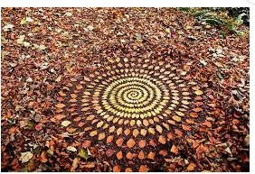
Make something – with a construction kit or a craft kit. Draw a picture of your model and label the parts  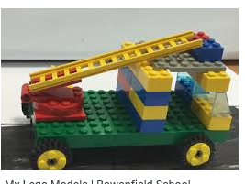 | Make a cake with your family. Remember to weigh the ingredients and use the words heavy or light   | Go on numbots and enjoy improving your number knowledge.  
Make your own game of snap using  Phase 4 tricky bit words  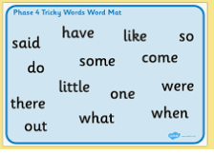 | Make a drink fit for a King. Remember to use the words full, empty, half full.  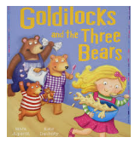 | Find objects around the home that are like the 3D shapes. How many can you find?  